We are absolutely thrilled you are interested to join us at Rohlik Group. By now we have spoken to you about your experience and personality in great detail. Next step is to find out how you tackle a task in reality.

**Supply chain specialist**

**Situation**

As supply chain specialist you are responsible for availability of the products as well as level of the stock. You will have 2 tasks and the aim is to come up with potential reasons and solutions which would maximize the availability and minimize the stock:

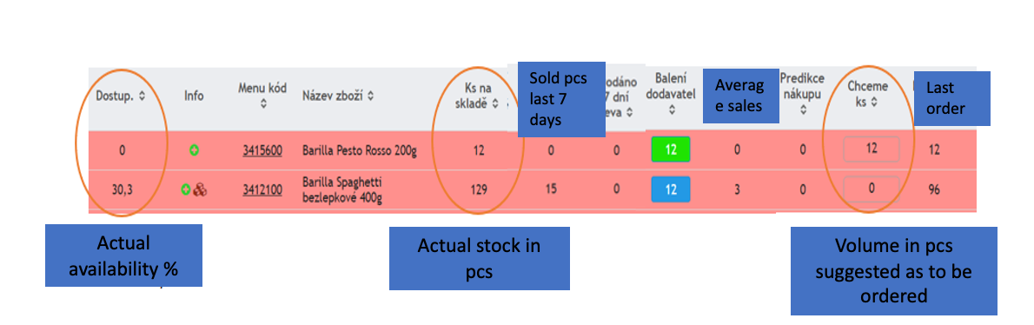

**Task**

* There are 2 products from Barilla - Pesto and Spaghetti, actual availability, actual stock and volume which the system suggests to order.
  + Why do you think actual availability is so low? Describe potential scenarios and how to fix them.
  + Would you change suggested volumes for ordering? If yes how much and why?
* How would you calculate ideal volumes for ordering those products? What would you take into account? How often you would want those products to be delievred?

**Additional Information**

* The exercise should not take you more than an hours to prepare.
* We will then go through the case study together during an interview/video call, the case study presentation should not take more than 20 minutes.

**Format**

We are not strictly set on the form of the presentation. Whatever works for you and you are comfortable with, works for us. So if you just want to have an open forum discussion without any materials, we are in. If you want to present any documents to us, we will provide the tools for it or bring your own. Just let us know.